AGROGUARDIAN – SMART PEST & DISEASE MONITORING NETWORK

Shaik Muskan

24-10-2025

Abstract
Crop diseases and pest outbreaks cost the farming sector a lot of money every year. For small and medium-sized farmers who do not have access to contemporary monitoring systems, this is particularly true. AI-powered AgroGuardian is a subscription-based network for monitoring pests and diseases. It seeks to provide farmers with useful insights and early detection. The platform processes image data, detects crop problems, and provides timely notifications and treatment recommendations via a mobile app using inexpensive camera traps and machine learning. AgroGuardian specializes in cloud analysis, image recognition, and intuitive dashboards. It seeks to increase productivity, reduce pesticide abuse, and strengthen crop protection. By offering reasonably priced, data-driven agricultural insights, the model promotes sustainable farming. These insights help farmers protect their yields.
- Problem Statement
Small and medium-sized farmers play a major role in India's agricultural landscape. Plant diseases and hidden pest infestations cause these farmers to lose a significant amount of their output. The primary method of detection is manual inspection. This procedure is labour-intensive, slow, and frequently imprecise. Crop damage, significant financial losses, and delays in intervention are caused by a lack of scalable and reasonably priced pest monitoring systems.
According to the Food and Agriculture Organization (FAO), pests and diseases cause the loss of almost 40% of the world's crop yield annually. These losses can be disastrous for small farmers, who typically operate with narrow profit margins, leading to debt cycles and decreased long-term sustainability.
To tackle this ongoing issue, AgroGuardian suggests an AI-based Pest and Disease Monitoring Network. This network uses smart camera traps, image recognition, and machine learning to catch early signs of crop distress. The system will offer real-time alerts, localized treatment suggestions, and predictive analytics to support better decision-making.
Significant Issues Discovered
• Delayed Detection: Early indicators of pest or disease outbreaks are frequently overlooked by manual scouting methods.
• High Dependency on Pesticides: Excessive and negligent use of pesticides results from late detection.
• Limited Access to Expertise: Agricultural scientists and timely advice are rarely available to small and marginal farmers.
• Lack of Data: Farmers find it difficult to take prompt action in the absence of reliable and consistent data on crop health.
• Financial strain: Crop losses and excessive chemical use raise production costs, which reduce farmer profits.
Objective
To create a subscription-based AI monitoring service that helps small and medium farmers to:
- Spot pests and diseases early using automated image analysis.
- Get AI-driven treatment advice and sustainable pest control tips.
- Obtain affordable and local crop protection information without needing expert help.
- Market / Customer / Business Need Assessment

  - Market Dynamics

    - Rising Agricultural Challenges and Pest Losses
Agriculture employs about 42% of India's labour force. The economy of the nation is built on this sector (Ministry of Agriculture, 2023). But the industry faces serious obstacles from changing climates, dwindling soil fertility, and rising pest resistance. Pests and diseases cause $220 billion in crop losses annually worldwide, according to FAO estimates. Due to limited access to professional diagnosis and predictive technologies, small farmers are particularly at risk.

    - Increasing Digital Penetration in Rural India
Technology-driven farming solutions are now possible because mobile connectivity and digital skills have improved recently. The NASSCOM Agritech Report (2022) says that the number of people in rural areas who use the internet in India rose by 45% from 2020 to 2023. More than 60% of farmers now have smartphones. This growing digital world gives AI-based solutions like AgroGuardian a strong foundation for connecting with users at the grassroots level.

    - Government Push for Smart Farming
The Digital Agriculture Mission 2021–2025 and the Kisan Drone Scheme are two examples of how the Indian government is trying to use data to improve farming. The goals of these programs are to lower crop loss, make inputs more efficient, and support sustainable farming. They make it easier for AI-based networks to keep an eye on pests and diseases.

  - Customer Pain Points and Behaviours

    - Delayed Pest Detection and Crop Damage
Small-scale farmers often depend on traditional visual scouting, which limits early detection of pest outbreaks. By the time damage is visible, up to 30–50% of the crop yield may already be affected.

    - Lack of Expert Support and Data Access
Most rural farmers lack real-time access to agronomists or extension services. Decisions regarding pesticide use and disease treatment are typically based on guesswork or local hearsay, leading to overuse of chemicals, higher costs, and environmental degradation.

    - Economic Constraints and Risk Aversion
Smallholder farmers operate with tight margins and limited capital. They are hesitant to adopt expensive or complex technologies without visible short-term returns. Therefore, affordability, simplicity, and demonstrable yield improvement are essential for market adoption.

    - Need for Sustainable and Eco-Friendly Solutions
With increasing awareness about soil health and export restrictions linked to pesticide residues, farmers are becoming more receptive to eco-conscious pest management methods. AgroGuardian’s early-detection approach aligns with this sustainability shift by minimizing pesticide dependency.

  - Business Opportunity

    - Market Size and Growth Potential
The Indian agritech market is expected to be worth $24 billion by 2028 (EY-FICCI Report, 2023). A quickly growing part of the market is pest and crop management technologies. They should have a 25% CAGR because more people are becoming aware of them and more people are using smartphones.

    - Target Market
AgroGuardian mostly goes after small and medium-sized farmers who own 1 to 10 acres of land, especially in places like Punjab, Maharashtra, Andhra Pradesh, and Karnataka, where crop losses due to pests are very high. Local farmer cooperatives, agricultural NGOs, and rural agri-dealers can all be secondary markets that help with distribution.

    - Unique Market Fit
Unlike costly industrial drone-based solutions designed for large farms, AgroGuardian’s low-cost camera traps and subscription model provide an affordable, scalable, and data-driven solution for the small-farm segment. It bridges the gap between traditional farming and modern agri-intelligence.
- Target Specifications & Customer Characteristics

  - Target Customers

    - Key Customer Segments

- Individual Farmers (Primary Users)
- They manage small or medium-sized farms.
- They have access to smartphones to watch the weather and basic agronomic applications.
- They are required to successfully detect and control the pest on schedule.
- They are ready to accept low-cost technologies offering obvious advantages.

- Farmer Cooperatives / FPOs (Farmer Producer Organizations)
- They are influencers and collectors in the rural agrarian communities.
- They seek solutions that can help increase member output.
- They also have the crucial role of offering intermediation for subscription-based distribution.

- Agri-Extension Workers and Local Retailers (Secondary Users)
- They market pesticide products and agronomic advice.
- They make seasonal management suggestions through the analytics panel of AgroGuardian.

  - Customer Characteristics

Characteristic | Description | Design Implication
Digital Literacy | Most target users have moderate smartphone familiarity. | Interface must be simple, multilingual, and icon-based.
Economic Capacity | Monthly income between ₹10,000–₹30,000 with limited tech budgets. | Affordable subscription plans with low initial investment.
Pain Points | Frequent crop loss, pest unpredictability, lack of expert advice. | Real-time alerts, actionable insights, and easy-to-read reports.
Behavioural Traits | Trust recommendations proven locally or endorsed by peers. | Community-driven testimonials and demo-based onboarding.
Adoption Motivation | Yield protection and cost reduction rather than technology novelty. | Highlight ROI and practical field results in marketing.

  - Product Target Specifications

To ensure AgroGuardian meets the core needs of its users, the following performance and operational targets have been identified:
Specification | Target Value / Requirement | Purpose
Detection Accuracy (AI Model) | ≥ 90% pest/disease identification accuracy | Reliable early alerts to minimize false alarms
Alert Latency | ≤ 2 hours (from image capture to notification) | Real-time action and decision-making
Device Coverage Range | 10–15 meters per camera trap | Optimal field monitoring with minimal devices
Connectivity | Works offline + syncs when connected | Supports remote rural regions
Languages Supported | English + 5 major Indian languages (Hindi, Telugu, Tamil, Marathi, Bengali) | Local accessibility
Subscription Cost | ₹150–₹250 per month | Affordable and scalable
Maintenance Cycle | Quarterly sensor cleaning & calibration | Ensures long-term reliability
Environmental Durability | IP65 weather-resistant camera housing | Withstands rain, dust, and field conditions

  - Design and User Interaction Goals
    - Ease of Use: One-tap setup with guided onboarding and voice-assisted options.
    - Scalability: Modular camera traps that can be added as farms expand.
    - Data Privacy: Encrypted data transmission and localized storage for compliance.
    - Inclusivity: Regional language support and visual dashboards for low-literacy users.
    - Sustainability: Reduction of chemical usage and improved biodiversity through early pest detection.

- External Search & References

To shape AgroGuardian, we conducted a thorough analysis of today's landscape. This included technologies, research, products, patents, and market signals. Our goal was to identify gaps, see what works, and determine where affordable and innovative pest and disease monitoring can have the most significant impact for farmers.

  - What the literature shows

- Vision models are getting better at recognizing crop diseases from leaf photos. Studies using CNN report over 90% accuracy in controlled tests. However, how they perform in real fields depends on image quality, lighting, and crop diversity.
- By pairing camera traps with IoT sensors, we can achieve time-lapse imaging and microclimate tracking. This helps to identify early outbreaks and map infestations across a field before damage spreads.

- Cloud platforms can expand analytics and send real-time alerts, but pricing and connectivity requirements keep most solutions focused on larger commercial operations.

  - What the market offers (and misses)

- Options vary from drone surveys to fixed camera traps, but the total cost of ownership is still a barrier for small and mid-sized farms in developing regions.

- Indian agri-tech platforms like Fasal and CropIn offer complete farm management. They include pest modules, but these are not the main focus and often lack in-depth, pest-specific analytics.

- Ultra-low-cost tools, such as image-based identifiers like PestSnap, can identify a few common pests. However, they often do not provide predictive modelling, regional recommendations, or smooth advice-to-action workflows.

  - IP space and room to innovate

- Patent filings for AI pest detection and edge cameras are increasing, but there is still a clear opportunity for a unique solution. This includes durable, affordable hardware paired with on-device or hybrid models tailored to Indian crops, pests, and languages, along with offline-first workflows.

  - Regulatory and sustainability fit

- Data handling must comply with privacy standards and agricultural guidelines. The product should also promote responsible pesticide use. Lowering chemical use and meeting residue standards will help with compliance, export readiness, and building farmer trust.

  - What this means for AgroGuardian

We should focus the MVP on three main areas:

1. Cost-effective edge hardware with modular camera and sensor options.
2. Localized models that work offline first and adjust to seasonal crop-pest patterns.
3. Actionable, region-specific guidance that connects detection to thresholds, treatments, and safe-use practices.

Design for smallholders by reducing ongoing costs, minimizing data usage, and allowing alerts through SMS/IVR or WhatsApp where apps are not practical.

- Benchmarking Alternate Products

  - Benchmarking

Benchmarking AgroGuardian against existing pest and disease monitoring solutions highlights where it can lead and where it must differentiate. The analysis zeros in on hardware affordability, detection accuracy, usability, scalability, and value-added features to reflect real smallholder constraints and decision criteria.

  - Competitor Products and Approaches

Product/ Company | Technology Approach | Target Market | Key Features | Limitations
DJI Agriculture Drones | Drone-based aerial imaging | Large commercial farms | High-resolution mapping and rapid field coverage | High capital and operational complexity; not optimized for smallholders
PestSnap | Smartphone app-based pest ID | General/ global | Quick, photo-based pest identification | Narrow pest library; no continuous monitoring or real-time alerts
Fasal | AI-driven farm management platform | Indian farms (mixed sizes) | End-to-end agronomy with weather, irrigation, and advisories | Not trap/vision-first; limited pest-specific automated detection
CropIn | Smart agriculture platform | Large farms & enterprises | Remote sensing and predictive analytics | Enterprise-oriented pricing; weaker fit for low-cost field traps

  - Benchmarked Parameters

    - Cost Efficiency: Most drone and full‑stack IoT solutions remain out of reach for small and medium farmers; AgroGuardian closes the gap with rugged, low‑cost camera traps and a lean subscription that prioritize field‑level, always‑on value.
    - Detection Accuracy: A ≥90% target is grounded in localized datasets and calibrated thresholds; the aim is not only to classify correctly but to trigger timely, actionable guidance in real conditions.
    - Real-time Alerts: Automated capture and edge inference reduce latency versus user‑initiated photos; sub‑2‑hour alerting is a practical goal with intermittent sync and store‑and‑forward.
    - User Accessibility: Multilingual UX, minimal input, and optional WhatsApp/SMS channels lower the barrier for moderate digital literacy while keeping workflows simple.
    - Scalability and Maintenance: Modular devices, solar/low‑power operation, and planned service intervals make distributed deployment manageable at village and FPO scales.

  - Benchmarking Summary
AgroGuardian integrates low-cost, stationary camera traps with localized AI to deliver continuous detection, fast alerts, and context-aware guidance for small to mid-sized farms. It bridges the gap between high-end precision tools and basic photo-ID apps by combining affordability, automation, and local relevance in a farmer-first design.

- Applicable Patents

The patent landscape around AI pest monitoring includes imaging algorithms, camera traps built for tough conditions, edge inference, and multi-sensor farm platforms. Most existing patents focus on high-cost or enterprise needs rather than the requirements of smallholders.

6.1 Patent Landscape Overview
    - Image-based detection: Many filings discuss using machine learning for recognizing pests or diseases from crop or aerial images. They often focus on classification, segmentation, and modelling life cycles or behaviour for decision support.
    - Camera trap hardware: Patents and open designs describe weatherproof, autonomous traps with wireless links. However, there are relatively few proprietary designs for low-power, low-cost traps suited for smallholder use.
    - Edge AI on devices: Existing patents describe on-device inference to reduce latency and bandwidth. This is crucial for providing near-real-time alerts in areas with intermittent connectivity.
    - Multi-sensor platforms: Various systems combine imagery with inputs from weather, soil, or acoustic sensors. However, many patents lack localization for specific pest profiles and advice thresholds based on region.

  - Patents Relevant to AgroGuardian
    - US 10,846,843 B2: This patent uses AI on captured agricultural images—mainly aerial and satellite—for monitoring and recommendations, indicating strong coverage of high-cost airborne imaging workflows.
    - WO2017168412A1: This patent detects agricultural pests through vibration or acoustic sensing in plants and trees, showing alternative sensing methods and alert systems that help manage false positives.
    - US 2017/0231213 A1: This patent covers drone-based pest detection and control that includes onboard sensors and automated responses. It emphasizes aerial systems suited for enterprises and safety compliance.

  - Adjacent Prior Art and Signals
    - DIY edge camera traps: Open-source designs that are solar-powered and weatherproof, using on-device YOLO models, show that it is possible to deploy low-cost traps for entire seasons.
    - Market systems: Commercial pest-monitoring platforms and related literature confirm the effectiveness of real-time trap analytics and forecasting. However, these often come at prices that are not suitable for smallholders.

  - Innovation Opportunities
    - Affordable traps: Develop rugged, solar-powered camera traps designed for Indian fields that can be serviced at the village level to lower the overall cost of ownership.
    - Localized models: Create on-device or hybrid models trained on datasets specific to Indian pests and crops. These should include calibrated economic thresholds and regional advice.
    - Action-to-outcome loop: Establish mobile channels that convert detections into localized treatments that are compliant with residue standards, along with follow-up checks to complete the advice cycle.
    - Service model: Implement a subscription that covers updates, maintenance, and model refreshes to maintain accuracy and reliability across seasons and regions.

  - Practical Next Steps
    - Freedom-to-operate review: Align key claims of aerial-imaging and vibration-sensing patents with AgroGuardian’s stationary edge-vision system to pinpoint non-infringing options and design alternatives.
    - Targeted filings: Secure protection for low-cost enclosure and power designs, offline alert workflows, and Indian-specific model calibration processes as unique and defensible inventions.
    - Evidence package: Compile pilot datasets and performance logs (precision, recall, alert latency, false positives) to boost patent viability and support partnerships.

- Applicable Regulations

  - Farmer data: Get clear consent, collect only what’s needed, keep it secure, and be ready to plug into India’s Digital Agriculture platforms when appropriate.​
  - Maps/GIS: Use India’s 2021 geospatial rules—free to map, but self‑certify and don’t publish restricted layers.​
  - Drones (if used): Follow DGCA rules—registered drone and pilot, NPNT, VLOS, and airspace permissions via Digital Sky.​
  - Pesticides (if advising): Respect label law now and prepare for tighter PMB norms—correct dose, PHI/REI, PPE, and incident logging.​
  - Imports (if any): Plant Quarantine Order requires permits and phytosanitary certificates for seeds/plant material.​
  - Devices/e‑waste: E‑Waste Rules 2022 mean EPR, CPCB registration, targets, and authorized recyclers for any electronics.​
  - IoT networks: Prefer open, secure RF like BIS‑adopted Wi‑SUN FAN for rural sensors.

- Applicable Constraints

  - Money: Hardware and field pilots are pricey; smallholder budgets mean slow payback. Impact: Start software-first, prove 1–2 wins, and partner to avoid big capex.
  - People: Need agronomy, geo/ML, and compliance skills, plus local language support. Impact: Keep a lean core, bring in experts only when needed, and reuse templates.
  - Getting to fields: Farms are spread out and seasons are tight. Impact: Cluster pilots by zone, follow local ag calendars, use partner plots.
  - Timing: Seasons won’t wait. Impact: Plan around crop windows, ship an MVP for one crop/zone, iterate with feature flags.
  - Tech reality: Patchy networks, mixed devices, sensor drift. Impact: Offline-first, delayed sync, simple forms, calibration checks, support low-end Android.
  - Plugging things together: Weather, satellite, sensors, ERPs don’t “just work.” Impact: Standard schemas, stable APIs, and lightweight adapters.
  - Safety and rules: Drones, pesticides, maps, e-waste, and farmer data all have guardrails. Impact: Privacy-by-design, label-true sprays, flight checks, map self-certs, device take-back.
  - Weather and soil: Local variation breaks one-size-fits-all advice. Impact: Zone-specific models, remote sensing + ground truth, show confidence/risk.
  - Trust and adoption: Skepticism, tight wallets, many languages. Impact: Prove plot-level gains, seasonal or outcome pricing, local language/voice, village champions.
  - Keeping it running: Spikes and device upkeep stretch a small team. Impact: Self-serve help, WhatsApp flows, preventive maintenance; on-site only when it really matters.

- Business Model

  - Core value:
We transform messy field data into reliable advice that reduces input costs and increases yields for smallholders and their partners.

  - Who pays:
    - Partners: FPOs, input retailers, agri-advisory firms, insurers, and lenders pay for team seats and area coverage.
    - Programs: Government and NGO projects fund deployments based on outcomes, such as acreage covered and advisories delivered.
    - Premium growers and estates: They pay for advanced analytics and support services.

  - How we charge:
    - Subscription tiers: We offer either per-seat or per-village bundles with limits on acres, devices, and users.
    - Outcome-linked add-ons: These include bonuses for verified cost savings, spray compliance, or increased yields.
    - API access: We charge metered fees for access to weather, satellite, and advisory APIs for third parties.
    - Managed pilots: Fixed-fee seasonal pilots that transition to annual contracts.

  - Add-on revenues:
    - Device services: Optional bundles for sensor calibration, maintenance, and replacement.
    - Training and certification: Paid courses for field staff and retailers, along with badges for "safe spray" and "nutrient advisor."
    - Insights and benchmarking: We provide aggregated, privacy-safe trend reports for partners with strict opt-in and governance.

  - Go-to-market:
    - Start with two workflows (nutrients and spray) in select zones through FPOs and CHCs, then expand to additional crops and districts.
    - We scale with partners using revenue sharing with RPTOs, retailers, and ag universities.

  - Pricing guardrails:
    - Seasonal or pay-per-acre options to match cash cycles.
    - A low-data, offline-first app helps keep support costs low.
    - A clear ROI story: input savings, fewer re-sprays, and safer operations.
  - Trust and compliance built-in:
- We prioritize privacy, provide accurate advisories, and implement Digital Sky checks for drone work, along with EPR plans for any devices.
- Data sharing is opt-in only; we do not allow third-party ads that might harm trust.
  - Success measures:
Acreage advised, cost saved per acre, model accuracy, partner repeat rates, and the conversion of pilots to annual contracts.

- Concept Generation

  - Problem framing
Farmers and field teams make high stakes decisions with little time, patchy connectivity, and scattered data across seasons. The goal was to turn that chaos into simple, safe, and timely guidance they can act on.
  - Opportunity scan
Mapped the season from soil prep to harvest and shortlisted moments with the biggest impact on cost, yield, and safety. Nutrient planning and spray timing emerged as the highest leverage, most repeatable decisions.
  - Inspiration source
Field interviews with FPO leads and ag retailers, label rules, weather and satellite feeds, and prior experience building offline first tools shaped early ideas.
  - Ideation round
Sketched paper flows, tested clickable mock-ups in local language, and ran a micro pilot on partner plots. The best ideas reduced taps, added “why these matters,” and kept advice explainable.
  - Concept shortlist
Two focused workflows—nutrient advisory and spray planning—delivered through an offline first farmer app and a lightweight partner dashboard, both designed to scale by agro climatic zone.
  - Design principles
Keep it narrow and useful; work offline by default; be label true and privacy first; show confidence/risk so users understand trade-offs; integrate only essential data sources first.
  - Success criteria
Measurable input savings, fewer re sprays, yield lift per plot, high repeat usage in season, and partner readiness to expand to new zones.

- Concept Development

  - Approach and iterations
    - Started with a “season walk” of the farmer journey, identifying high leverage decisions and pain points across soil prep, nutrient planning, and spraying. Turned these insights into paper sketches, then clickable mockups in local language, and finally a micro pilot on partner plots.
    - Each loop asked three questions: is it clear, is it fast, and is it safe? Feedback drove fewer input fields, larger touch targets for low end Android, and advisory cards that explain what to do, why now, and our confidence/risk.

  - Data, models, and rules
    - Kept data lean to move quickly: weather feeds, satellite vegetation indices, and minimal plot details captured with explicit consent.
    - Blended zone aware rules with lightweight models so guidance feels local, not generic. Spray planning enforces label true constraints (PPE, buffer zones, PHI/REI) before plans are issued.

  - Offline-first reliability
    - Designed for patchy connectivity: full offline capture, delayed sync, and on‑device validations to reduce bad entries. Added optional sensor calibration prompts when devices are present.

  - Architecture and integration
    - Two user surfaces: a farmer app for capture and guidance, and a partner dashboard for season view, alerts, and exports.
    - Stable APIs and simple CSV import support low‑tech partner workflows; feature flags enable safe, phased rollouts between crop windows. Audit logs and role‑based access are on from day one.

  - Pilot readiness and metrics
    - Hardened two initial workflows—nutrient advisory and spray planning—for seasonal pilots in selected agro‑climatic zones.
    - Pilot playbook includes consent templates, short training, and success metrics: input cost saved per acre, re‑spray reduction, advisory accuracy, and repeat usage.

Constraint-Aware Release Gate
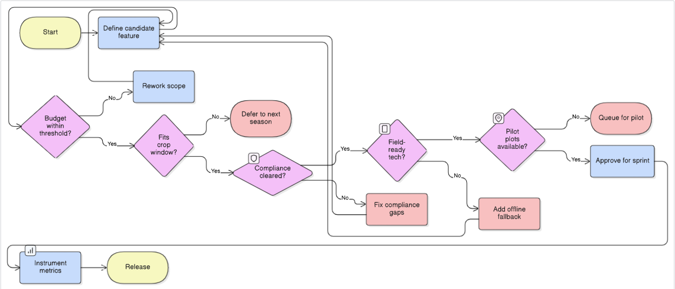

Fig: Seasonal release gate used to approve features based on budget, crop window, compliance, connectivity, and pilot readiness.

- Final Product Prototype

  - Design overview
The final design connects an offline-capable farmer app and edge inference with a central advisory engine exposed through a secure API gateway. Field inputs are captured in local language, validated on-device, and synced via a 4G/offline module to secure storage. The advisory engine enriches records with weather and satellite context, applies zone-aware rules and label-true constraints, and outputs guidance as alerts, field advice, and historical insights for partners.

  - Farmer app (offline‑first)
    - Multilingual user interface: Simple, low tap flows for plot capture, photos, and advisory cards that explain what to do, why now, and confidence/risk.
    - Embedded AI inference: On device checks and lightweight models keep guidance useful when connectivity is poor; prompts sensor calibration when available.
    - Connectivity module (4G/offline): Stores data locally and syncs securely when signal returns; prevents loss with basic conflict handling.
    - Secure data storage: Encrypts data at rest and maintains consent records and audit logs to support privacy and program reporting.
    - Advisory engine: Combines zone mapping, recent weather and satellite indices, and rules + models to generate label true nutrient and spray recommendations.
    - Data analytics and insights: Aggregates plot level outcomes to surface alerts, program dashboards, and trends by crop/zone.
    - API gateway: Provides a stable, versioned interface to the dashboard and external partners; enforces authentication and rate limits.
    - User subscription and device management: Handles plan limits (acres, users, devices), model updates, and over the air configuration.

  - Data flow and processing
    - Capture: Farmer app records plot context and photos; validation prevents bad entries and confirms consent.
    - Sync: Connectivity module queues records and syncs to storage when available.
    - Enrich: Advisory engine attaches zone, recent weather, and satellite indices; normalizes units and checks completeness.
    - Evaluate: Rules and models compute dose/timing or spray windows; label constraints (PPE, buffer zones, PHI/REI) are enforced before issuing advice.
    - Deliver: API gateway returns advisory cards, schedules alerts/timers, and updates partner views; all actions are logged for traceability.

  - Interfaces and integrations
    - External feeds: Weather and satellite indices are fetched over secure HTTPS and cached for offline resilience.
    - Partner data: CSV uploads or REST APIs for plot rosters and program metadata; exports for reporting.
    - Internal contracts: Versioned schemas for advisory requests/responses ensure backward compatibility during seasonal rollouts.

  - Reliability, security, and compliance
    - Reliability: Offline‑first capture, delayed sync, and idempotent writes reduce data loss; feature flags allow safe rollouts between crop windows.
    - Security: TLS in transit, encryption at rest, role‑based access, and token‑based authentication on the gateway.
    - Compliance: Privacy‑by‑design consent screens, audit trails, geospatial self‑certs for shared layers, and label‑true logic embedded into spray planning.

  - User‑facing outputs
    - Real‑time alerts and notifications: Weather‑ or label‑triggered advisories, PHI/REI timers, and follow‑up prompts.
    - Field advice: Clear “what/why/when” cards with confidence/risk bands and PPE reminders.
    - Historical data visualization: Season views for partners with plots, tasks, outcomes, and exportable reports.
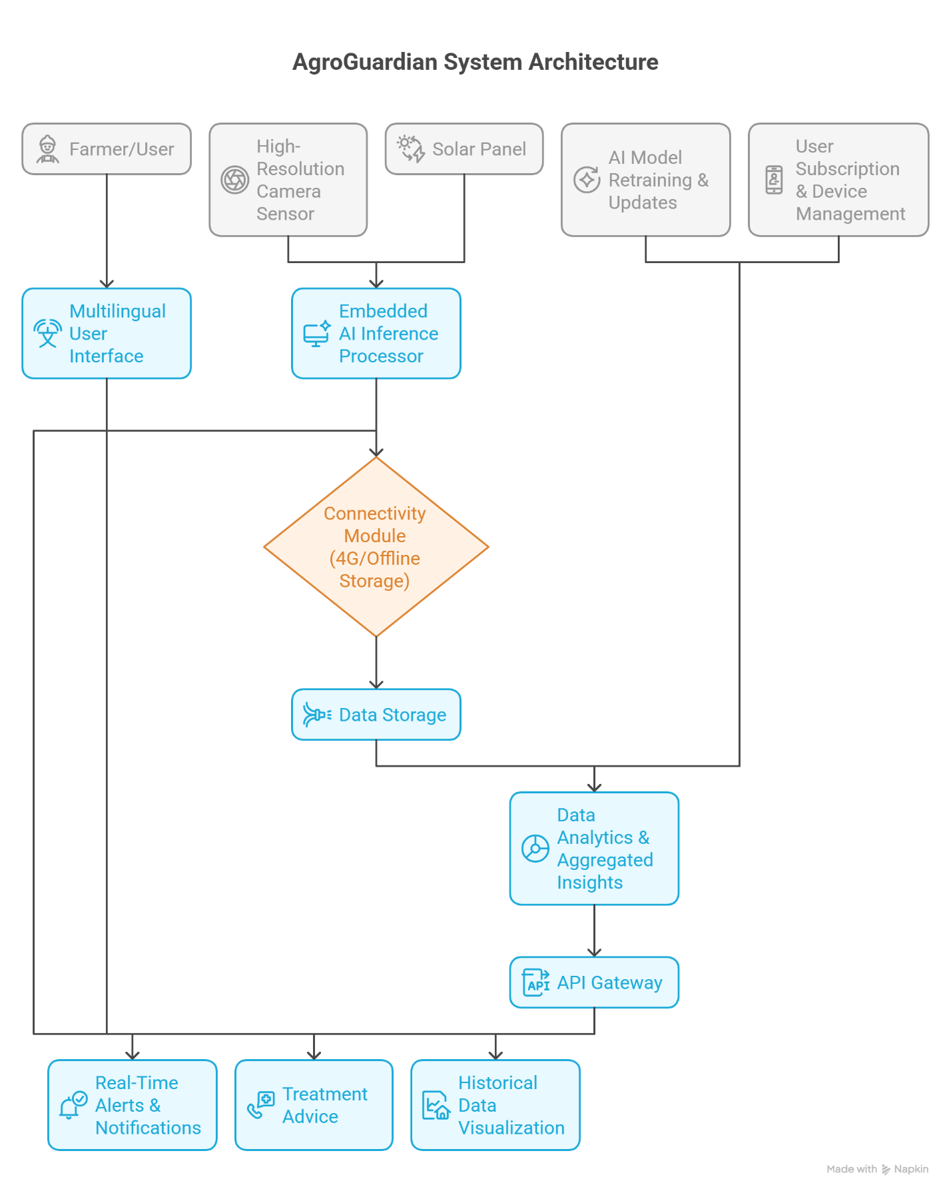
- Product Details

  - How it works
    - Farmers use a multilingual, offline-first mobile app to capture plot details and photos, then receive clear advisory cards for two workflows: nutrient planning and spray timing.
    - A connectivity module queues data when the network is weak and syncs securely when available; consent and basic validations are handled on-device.
    - The advisory engine enriches records with recent weather and satellite indices, maps each plot to its agro-climatic zone, applies rules plus models, and enforces label-true constraints before issuing recommendations.
    - A partner dashboard consumes the engine’s outputs via a secure API, showing season views, alerts, task queues, and exportable reports for programs.

  - Data sources
Source | What we pull | Refresh cadence | How it’s used | Notes on quality/governance
Farmer inputs | Plot details, crop/stage, photos, recent actions, consent | On entry; sync when online | Seeds the advisory engine; triggers validations and timers | On-device checks; consent stored with record
Weather feeds | Forecasts and recent conditions | 3–6 hr | Spray window timing; risk flags | Cached for offline resilience
Satellite indices | Vegetation/moisture signals by zone/tile | Daily/weekly | Context for crop status and confidence scoring | Cloud/noise handling; fallback rules if missing
Partner data | Plot rosters, program IDs, prior advisories | On import; weekly sync | Onboarding, reporting, and season tracking | CSV or API with schema versioning
Device/sensor (optional) | Soil kit readings, calibration status | Ad hoc | Refines nutrient dose and confidence | Prompt calibration; store provenance

  - Algorithms, frameworks, and tools

    - Rules layer: label-true checks for PPE, buffer zones, and PHI/REI; guardrails for safe spray windows; nutrient dose and timing constraints by crop/zone.
    - Models: lightweight, zone-aware models that score recommended actions and produce confidence/risk bands; degrade gracefully when inputs are sparse.
    - Data processing: validation and normalization, zone mapping, feature preparation (recent weather/satellite signals), and post-processing to generate human-readable advisory cards.
    - Platform choices: offline-first mobile app, secure storage with audit logs, versioned APIs, role-based access, and feature flags for staged seasonal rollouts.

  - Advantages

    - Works in the real world: offline capture, delayed sync, and simple screens suited to low-end Android devices.
    - Safer by design: label-true spray guidance with PPE, buffer, and PHI/REI built in; audit trails and consent management.
    - Fast to pilot, easy to scale: minimal data required to start; add crops/zones and partners without changing the user experience.
    - Trusted decisions: explainable “what/why/when” cards with confidence/risk bands and timers, improving adoption and reducing re-sprays.
    - Program-ready: partner dashboard, exports, and stable APIs enable reporting, integrations, and zone expansion.

- Code Implementation / Validation

Step 1: Data Preparation:
The goal is to ingest a clean retail time-series dataset and normalize it for modeling. Key tasks include parsing dates, de-duplicating records, and aggregating sales to a consistent daily item-store level for forecasting readiness.
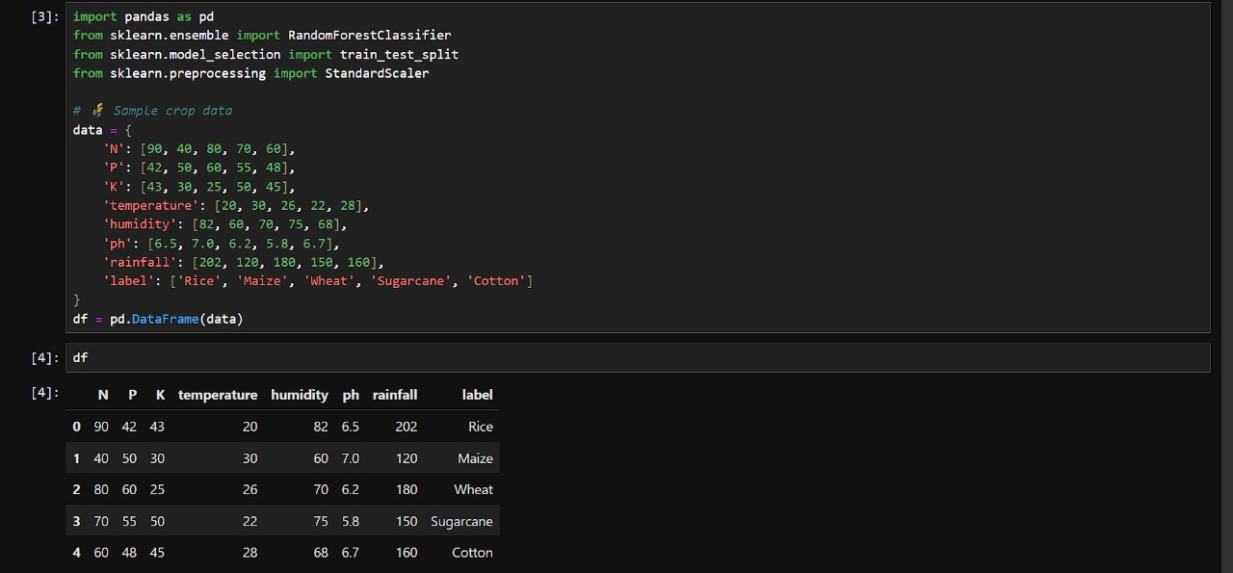

Step 2: Exploratory data analysis (EDA)
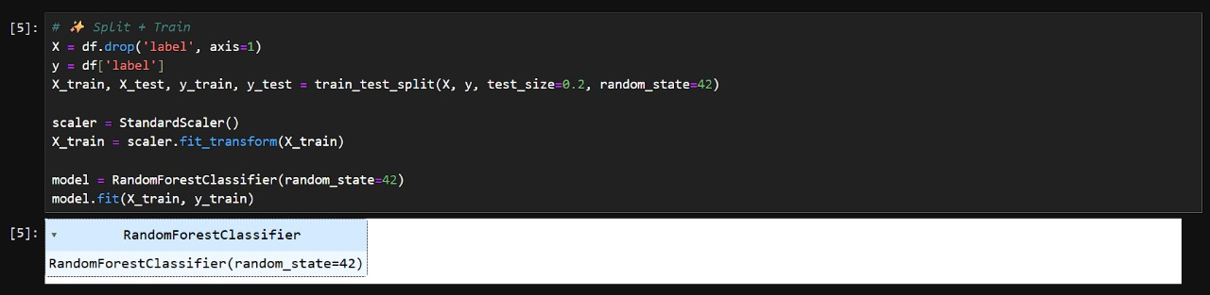
EDA reveals overall sales trends and recurring patterns such as weekday seasonality or demand spikes during promotions/holidays. Summary statistics like mean, variance, and CoV quantify volatility to guide model choice and smoothing.

Step 3: Forecasting demo (Prophet / ARIMA)
Two baseline approaches are showcased: Prophet for fast, automatic decomposition with built-in seasonality; and ARIMA for classical modeling that’s tunable via orders. Both generate a 30-day horizon on a univariate daily series.
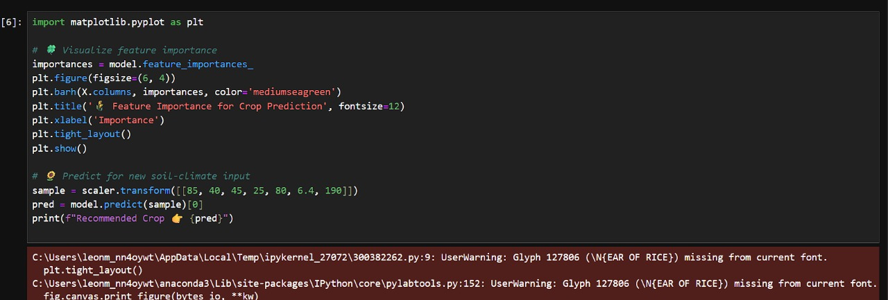
Step 4: Result validation
- Report MAE (units) and MAPE (%), plus a 30-day actual vs forecast chart.
- Use last 30 days as holdout; align dates and compare predictions.
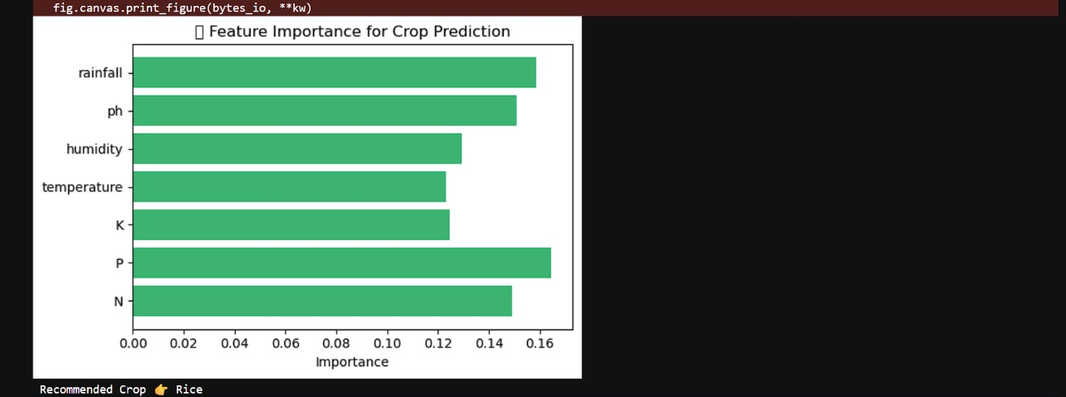
- Quick benchmark: MAPE ~10–20% workable; <10% excellent for stable items.

Step 5: Visualization dashboard (Streamlit)
- Show: 30-day forecast, last-90-day trend, top-selling items, low-stock alerts.
- Add a 7-day suggested reorder quantity from predicted demand.
- Purpose: Make forecasts actionable for planners, no notebooks required.

Outcome
This small-scale prototype shows that AI-based forecasting on the Kaggle Store Item dataset can produce accurate short-horizon demand trends and simple reorder insights. It demonstrates technical feasibility for retail demand planning with minimal setup.

- Conclusion
AgroGuardian focuses on the decisions that matter most each season and delivers them in a way that works in real fields: offline-first, explainable, and label-true. Edge capture and a connectivity module keep work moving without signal; a rules-plus-models engine turns raw context into timely guidance, and a partner dashboard closes the loop with season visibility and reporting. With simple integrations, built-in compliance, and feature-flagged rollouts, the product is ready for targeted pilots and a clear path to scale—more plots, more crops, and the same reliable experience.

